Welcome!
Date
Name
Spouse
Address
City
State Zip _________
Email

Please Contact By
❑ Card  Phone  Visit

Telephone Best Time to Call
Home ______________
Work ______________

Guest: First Time Second Time
Are you a church member: yes no
Church
City, State

Circle Appropriate Age/Grade Group(s)
Preschool: Ages: B-1 2-3 4-5
Children: Grades: K 1 2 3 4 5 6
Youth: Grades: 7 8 9 10 11 12
Adults: Ages:18-29 30s 40s 50s 60s+

How did you learn about our church?
Newspaper Friend Yellow Pages Mail
Other

I am a guest of:

New in the Community? Yes No
Names & ages of children at home

Weekly Service & Activity Schedule

Nov 12, 2017
9:30 a.m. New Commandment Kids
9:45 a.m. Sunday School
11:00 a.m. Worship Service
6:00 p.m. Evening Video/Business Meeting

Week of Nov 12, 2017
Wednesday 6:30 pm……………..……….Meal/Bible Study
Friday 6:30 pm……………..……………..Men’s 42 Night
November
13-15…………..……….BGCT Annual Meeting (Waco)
23……………………………….…………..Thanksgiving
December
3………………………..……New Commandment Kids
3…....Sr Women & Men’s SS Class Christmas Lunch
3-10……….Week of Prayer for Lottie Moon Missions
10……………………………New Commandment Kids
10………………..………………….Christmas Program

Thanksgiving Boxes
We are still collecting food items for Thanksgiving boxes to give to the less fortunate in our community. See Cherilyn Wilson for a list of items still needed.

Christmas Program
December 10th during the evening service
If you would like to participate in the program, there is a sign-up sheet in the sanctuary.

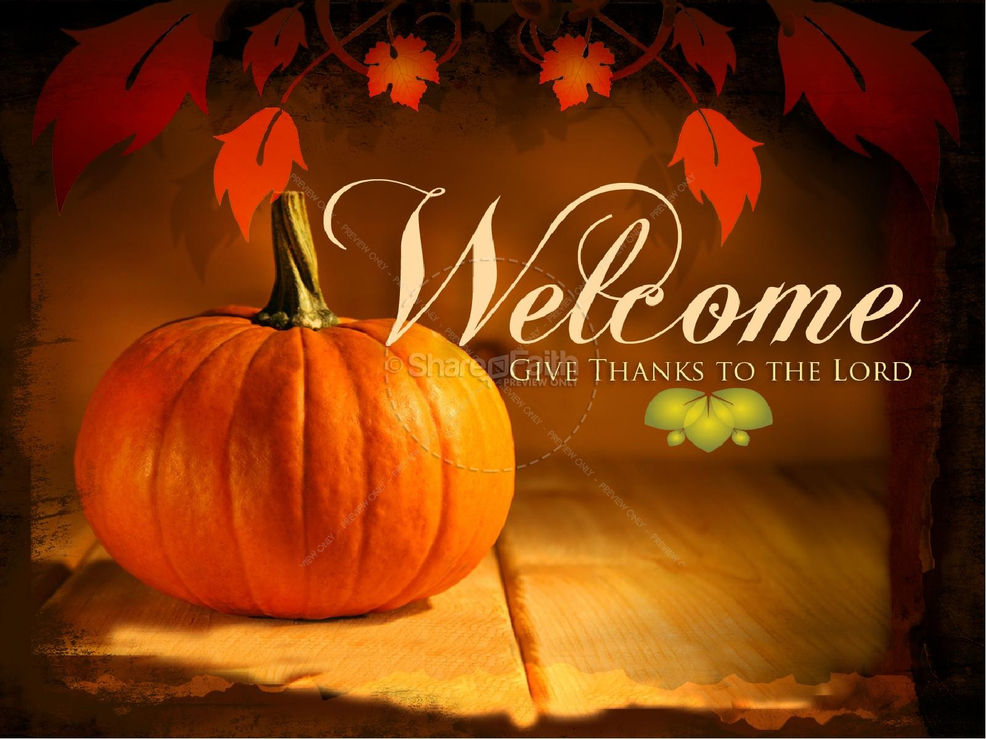

Knobbs Springs Baptist Church

Nov 12, 2017

Church Information:

KnobbsSpringsBC.com KnobbsSpringsBaptist@gmail.com

1662 CR 305, McDade, Texas 78650 512-273-2743

David Atwood, Pastor Cell 512-470-5098

Patti Radford, Office Manager Cell 512-968-7821

